American Bar Association
Forum on the Construction Industry

Workshop F: Who is Allowed on the Dock?
What Construction Counsel Need to Know About E-Verify and Immigration Enforcement

Part 1:
Why the I-9?: Completing, Retaining and Auditing
the I-9 Employment Eligibility Form

Part 2:
E-Verify: What Is It, Why Do You Care, and When Can You Be Required To Use It?

Erin L. Ebeler
Woods & Aitken LLP
Lincoln, Nebraska

Andrea G. Woods
Nabholz Construction Services
Conway, Arkansas

Presented at the 2012 Fall Meeting

Construction Counseling: Pulling Together for a Winning Strategy

October 18-19, 2012
Sheraton Boston Hotel, Boston, Massachusetts

The Immigration Reform and Control Act (“IRCA”) of 1986 prohibits employers from knowingly hiring illegal workers. In recent years, enforcement of these laws has increased, making it all the more important that employers know their obligations under the law and understand the risk of non-compliance. For example, the graphs below from a May 2, 2012 article in the Wall Street Journal illustrate the increased enforcement efforts, as well as the financial and criminal penalties that will face employers who employ unauthorized workers. The purpose of this paper is to explain the fundamental compliance mechanisms employers have to ensure they avoid being such a statistic.
Image 1: ICE Turns Up the Heat
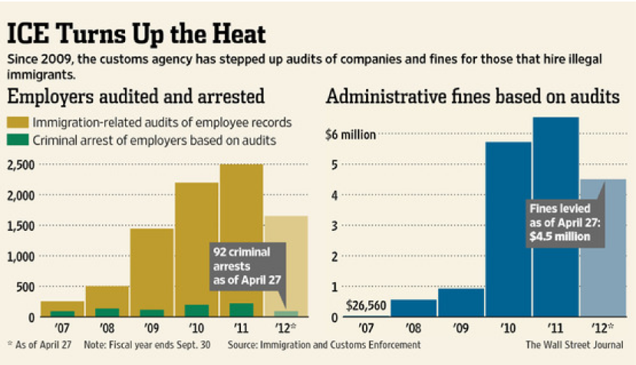
Workshop F: Part 1
Why the I-9?: Completing, Retaining and Auditing
the I-9 Employment Eligibility Form

Andrea G. Woods
Nabholz Construction Services

- An Introduction to Form I-9
The Immigration and Control Act of 1986 (“IRCA”) was passed to control and deter illegal immigration to the United States. The most significant provisions of IRCA stipulate legalization of undocumented aliens who had been continuously unlawfully present since 1982, legalization of certain agricultural workers, sanctions for employers who knowingly hire undocumented workers, and increased enforcement at U.S. borders.
To ensure compliance with the prohibition on employers from knowingly hiring or continuing to employ an unauthorized worker, IRCA imposes certain documentation obligations on employers, commonly known as Form I-9s. Generally, employers must examine various identification documents of every person they hire after November 6, 1986 for employment in the United States. Individuals hired before November 6, 1986, with continuing employment have a reasonable expectation of employment at all times. In addition, individuals performing casual domestic work performed in private homes on a sporadic, irregular, or intermittent basis, independent contractors or individuals providing work through a leasing or temporary staffing agency, and individuals not physically working in the United States are excluded from the Form I-9 requirement.
Employers must verify that documents provided by individuals “reasonably appear on [their] face to be genuine.” This verification should be accomplished through completion of an I-9 form. Employers who violate IRCA can face civil penalties or even criminal prosecution.
In 2011, ICE issued over 300 final orders against employers for I-9 worksite violations totaling more than $9million in fines. ICE reports that employers should expect even more, approximately 3,000, Notices of Inspection to be issued in 2012.
- Completion of the I-9
Employers must ensure that employees complete and sign Section I of the I-9 no later than the first day of work for pay. If a job offer has been made and accepted, the employer may obtain the I-9 prior to the first day of work. Employers must provide employees with a copy of the I-9, along with the completion instructions and List of Acceptable Documents that may be submitted for verification. The employee section of the form requests basic personal identifying information, including the employee’s social security number unless, as addressed in Part 2 of this paper, the employer participates in E-Verify and the individual employee is issued a number. The employee himself/herself must sign and date the form, regardless of whether they received translator or other assistance in its completion.
Unintentional errors often occur during completion of Section I of the I-9, and employers are ultimately responsible for assuring the form is completed accurately, and without errors. Accordingly, the employer must review the employee-provided information, assure all required fields are completed, assure the employee signed and dated the form, and that any translator/preparer section is completed, dated and signed. Special attention should be given to whether employees indicate that their employment authorization will expire. Employers may need to re-verify this authorization and provide the employee a 90 – 120 day reminder to provide updated verification or a List A or C document to show continued employment authorization for re-verification on the date their current authorization expires.
Section 2 requires that the employee provide unexpired original documentation showing their identity and employment authorization. The employee must make a selection of (1) one document from List A, or (2) one selection from List B in combination with one selection from List C. List A documents show both identity and authorization for employment, while List B documents show identity, and List C documents show work authorization. Note that employer representatives often receive “receipts” from employees indicating they lost an acceptable document and have requested a new one. Such receipts may only be accepted as a temporary measure and cannot substitute for the original document.
Employers are required to physically examine the original documentation and signing the form. The employer must, within three business days of the employee’s first day of work for pay:
- Ensure that each document presented is on the List of Acceptable Documents or is an acceptable receipt.
- Physically examine each document to determine if it reasonably appears to be genuine and relates to the presenting employee. If the document is rejected for failing to meet this criteria, the employer should permit the employee to present alternate documentation from the List of Acceptable Documents.
- Record the document title, issuing authority, number(s), expiration date (if any) from the original document(s) the employee presented.
- Enter the date the employee began or will begin work for pay.
- Provide the name, signature and title of the employer representative completing Section 2, and the date the form is signed.
- Record the employer’s business name and address.
- Return the documentation provided to the employee.
If the employee is a minor, lists a disability requiring assistance, or presents documentation that is not familiar to the employer representative, guidance should be sought from legal counsel or the United States Citizenship and Immigration Services (“USCIS”).
Section 2 requires that the date the employee began work for pay be entered, and this can lead to confusion in some circumstances because the date may be a current, past or future date. USCIS provides the following guidance:
Employers should enter:
- A current date if Section 2 is completed the same day the employee begins work for pay.
- A past date if Section 2 is completed after the employee began work for pay. Enter the actual date the employee began work for pay.
- Federal contractors completing Form I-9 for existing employees as a result of an award of a federal contract with the FAR E-Verify clause should enter the date employees first began work for pay from Section 2 of their previously completed Form I-9.
- A future date if Section 2 is completed after the employee accepts the job offer but before he or she will begin work for pay. Enter the date the employee expects to begin work for pay. If the employee begins working for pay on a different date, cross out the expected start date and write in the correct start date. Date and initial the correction.
Image 2: Three Day Rule
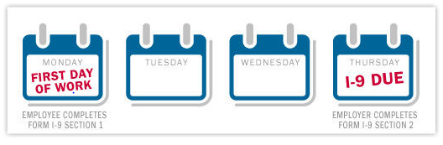
Training of employee representatives completing the I-9 is encouraged. The Handbook for Employers, Form M-274, is of great assistance with employee training efforts and should be consulted. USCIS cites a multitude of “common errors” on its website, many of which are errors one could describe as simple, inadvertent oversights, such as failure to date the form when signed or properly identify the Acceptable Document provided. With staunch penalties for violations on a per form basis, this could cause significant financial and administrative disruption to an employer. Detailed charts of possible penalty ranges are provided in Subpart IV of this section of the paper. Suffice it to say, however, the penalties can be substantial. Since January 2009, Immigration and Customs Enforcement agency (“ICE”) has investigated more than 7,500 employers and in 2011 alone imposed more than $6 million in fines.
In addition to the potential for penalties for failure to comply with the Form I-9 requirements, employers can also be held liable for violations of the Immigration and Nationality Act (“INA”). Employers are prohibited from treating individuals differently based upon citizenship status or national origin in the I-9 process. Also referred to as “document abuse,” these practices may constitute unlawful activity:
- Requesting that employees produce more documents than are required by the I-9 to establish the employee’s identity and work authorization;
- Requesting that employees produce a particular document to establish identity or work authorization;
- Rejecting documents that reasonably appear genuine and relate to the individual presenting them; and
- Treating groups of applicants differently when completing the Form I-9, such as requesting that applicants who look or sound “foreign” provide a particular document others are not required to present.
Section 3 of the I-9 must be completed when an employee’s authorization or authorization documentation has expired, an employee is rehired within three years of the date the original I-9 was completed, and when an employee changes his or her name. If an authorization expiration date in Section 1 does not match the document expiration date recorded in Section 2, the earlier date should be used to determine whether reverification is necessary. It is good practice to remind employees 90 or more days in advance the date reverification is required that they will need to present a List A or List C document indicating their employment authorization is continued. U.S. Citizens, lawful permanent residents with a Permanent Resident Card for Section 2, and List B documents should not be reverified.
It is not uncommon for an employee to return to work for an employer. If this occurs within three years from the date the employee’s original Form I-9 was completed, an employer may complete a new form I-9 for the employee or complete Section 3 of the original I-9. The employer is responsible for confirming the original I-9 relates to the employee, determine the employee is authorized to work and that documentation previously presented is valid, and sign and date Section 3. If previous documentation is no longer valid, reverification may be required.
When an employee changes his or her name, the employer is not required to note the name change on the I-9. If the employer is already completing Section 3 for reverifying or rehire purposes, the employer should note the name change, the reason therefor (if provided by employee), and maintain any proof of name change the employee voluntarily provides. Note that there is no requirement that employees show proof of a name change for the Form I-9.
Section 3 has two locations where the employer records the following dates: the date the former employee is rehired (when the employee begins work for pay or appropriate future date); and the attestation date (the date the employer records the rehire data and/or completes reverification.
- Document Retention

Employers are required to maintain employee I-9s throughout their employment. Once the employee’s employment is terminated, the employer may destroy the I-9 (1) three years after the date of hire, or (2) or one year after the date of termination, whichever is later. A simple 3-ring binder can provide sufficient storage organization and tracking of which I-9s are next in the cycle for destruction.
These records may be maintained in paper form, microfiche, or electronically. If the employer elects to maintain the records electronically, they must be maintained in accordance with DHS standards. Electronically maintained records are equally subject to inspection and audit by enforcement agencies. In 2010, Abercrombie and Fitch paid $1,047,110 in fines to settle with the U.S Immigration and Custom Enforcement’s (ICE) Office of Homeland Security Investigation (HIS) division in Abercrombie & Fitch’s electronic I-9 verification system.
Multi-jurisdictional employers should assure that the I-9 retention process is consistent amongst the various locations or is centralized to assure that internal, as well as any agency, audits can be completed in a prompt, organized fashion. Audits are a key component for an employer to show good faith efforts at compliance with its requirements under the law. An exhibit to this paper provides an example Audit Checklist that can be used when conducting an internal audit.
- Investigation by the Government
So, what happens when the “Men in Black” come to investigate the employer’s Forms I-9? At the point that the investigation begins, it will be very important for employers’ and their lawyers to appreciate the anticipated process and to understand employers’ rights throughout that process. Generally speaking, U.S. Immigration and Customs Enforcement (“ICE”) is the investigative arm of the Department of Homeland Security. ICE has provided the following flow chart of anticipated activities over the course of an investigation:
Image 4: ICE Investigative Process
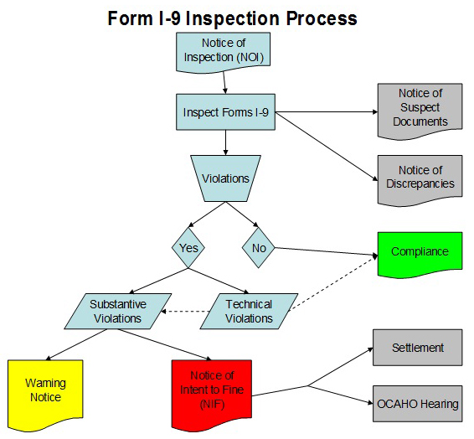
With regard to the first step in the process, the Notice of Inspection, ICE will initiate an investigation either sua sponte or as a result of a third-party complaint. In doing so, however, ICE must generally provide an employer three (3) business days notice prior to the inspection of Forms I-9 occurring. Notably, however, if a subpoena or warrant is issued and presented, the employer may not have that three (3) day warning period. Given the limited time frames involved, a previously completed internal audit is essential to limiting the fines and penalties, but also important in enabling an employer to meet their obligations in response to an investigation.
At the end of the investigation, a Notice of Intent to Fine may be issued. The penalties for violations include those for knowingly hiring or continuing to employ unauthorized workers as well as substantive and technical violations on the Forms I-9 themselves. Generally speaking, the amount of the violations are going to be determined based upon the percentage of errors as well as a company’s prior history (or lack thereof) of violations.
Image 5: Penalties for Knowing Hire /
Continuing to Employ Fine Schedule
(for violations occurring on or after 03/27/2008)
 | Standard Fine Amount
Knowing Hire and Continuing to Employ Violations | First Tier  $375 – $3,200 | Second Tier  $3,200 – $6,500 | Third Tier  $4,300 – $16,000
0% – 9% | $375 | $3,200 | $4,300
10% – 19% | $845 | $3,750 | $6,250
20% – 29% | $1,315 | $4,300 | $8,200
30% – 39% | $1,785 | $4,850 | $10,150
40% – 49% | $2,255 | $5,400 | $12,100
50% or more | $2,725 | $5,950 | $14,050

Image 6: Substantive / Uncorrected Technical Violation Fine Schedule
 | Standard Fine Amount
Substantive Verification Violations | 1st Offense  $110 – $1100 | 2nd Offense  $110 – $1100 | 3rd Offense +  $110 – $1100
0% – 9% | $110 | $550 | $1,100
10% – 19% | $275 | $650 | $1,100
20% – 29% | $440 | $750 | $1,100
30% – 39% | $605 | $850 | $1,100
40% – 49% | $770 | $950 | $1,100
50% or more | $935 | $1,100 | $1,100

In the event that a Notice of Intent to Fine is issued as a result of a government investigation, the employer will have 30 days to file a written request for a hearing before an Administrative Law Judge.
Workshop F: Part 2
E-Verify: What is it, why do you care, and when can you be required to use it?

Erin Ebeler
Woods & Aitken LLP

- Introduction
Unauthorized immigration has been a contentious issue in the United States for many years, and the employment of unauthorized workers has been especially contentious. In the 1980s, Congress sought to address this issue by prohibiting the knowing employment of undocumented workers.
E-Verify is a federal online program which allows employers to check the work-authorization status of their employees and provides employers with a way to minimize their risk of liability for employing undocumented workers. Some employers may even be required to use E-Verify under federal and state laws. In particular, construction contractors that are the recipient of federal monies are often targeted with E-Verify requirements by the federal and state governments. Thus, construction companies and their lawyers need to know and understand employer rights and responsibilities are when it comes to E-Verify. This section of the paper will discuss what E-Verify is, who is required to use it, why employers might want to use it even if not required to do so, and how employers should use it. Certain state laws will be evaluated as well to provide a flavor for state law approaches to this issue and to illustrate that employers must be cognizant of the different rules as they perform work in different states.
- What is E-Verify?
Broadly speaking, E-Verify is intended to help employers comply with their obligations under the Immigration and Control Act of 1986 (“IRCA”). Generally, IRCA prohibits employers from knowingly hiring or continuing to employ an unauthorized worker. To ensure compliance with this prohibition, IRCA also imposes certain documentation obligations on employers, commonly known as Form I-9s. As discussed in Part I of this Article, employers must examine various identification documents of the employee, and verify that such documents “reasonably appear on [their] face to be genuine.” This verification is done through the completion of an I-9 form. Employers who violate IRCA can face civil penalties or even criminal prosecution.
E-Verify was implemented under the Illegal Immigration Reform and Immigrant Responsibility Act of 1996 as an additional means for employers to verify the work authorization status of their employees. Essentially, E-Verify uses an internet-based system to compare information from an employee’s Form I-9 to 80 million records belonging to the U.S. Department of Homeland Security (“DHS”) and 455 million records belonging to the Social Security Administration (“SSA”) to confirm employment eligibility.
- How Does E-Verify Work?
When using E-Verify, an employer uses the E-Verify website to enter information from the employee’s I-9 form, which is then cross-checked against government databases. “Employment Authorized” results will be returned if entered information contained in the government databases, which employers may want to print and attach to the employee’s I-9 form. Employers will see a screen similar to Image 1 when employment is authorized.
Image 7: Employment Authorized Screenshot
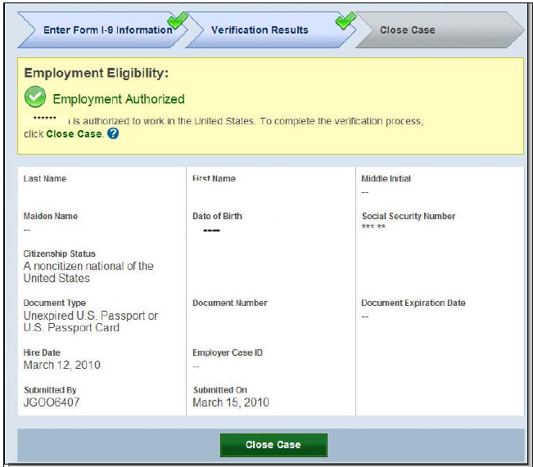
However, an employer may also receive a wide number of other alerts. For instance, it may be that the employee’s information simply does not match DHS records. At that time, the case is referred to DHS for additional processing, which may take up to three “federal government workdays.”
Image 8: DHS Verification in Process
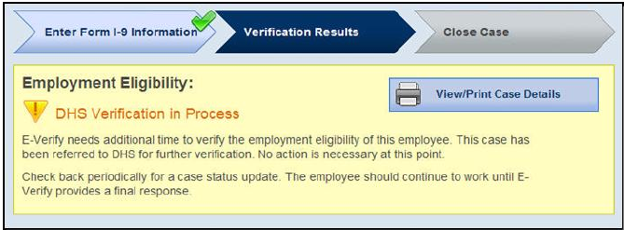
During the verification process, no adverse action may be taken against an employee, and one of three events will next occur: (1) the employee’s employment will be authorized, (2) the DHS will issue a Tentative Nonconfirmation (discussed below), or (3) the employer will receive a notice that the DHS Case is “in continuance.” Cases in continuance may be the result of a wide number of circumstances, and an employer’s only option is to keep checking E-Verify until a final result is reached. During this time, an employee must be allowed to continue working.
Mismatches to the government’s database result in a “Tentative Nonconfirmations” (“TNC”) from the Department of Homeland Security and/or the Social Security Administration. In the event that a TNC is received, E-Verify will generate specific paperwork that the employer must review with the employee. An employee may contest the result of a TNC, and he or she must be allowed to continue working during this contested period.
During this process, one of the most dangerous times for employers is during the pendency of when an employee has the right to contest a TNC. Employers must not take adverse action against an employee solely as a result of a TNC and to the extent they do so, they may be found to have engaged in discrimination. E-Verify will walk employers through a number of screens, and it is important for employers to follow the instructions on those screens closely.
Image 9: DHS Tentative Nonconfirmation Initially Received
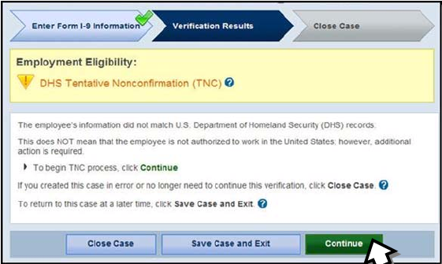
Image 10: DHS Tentative Nonconfirmation—Employee Notification Process
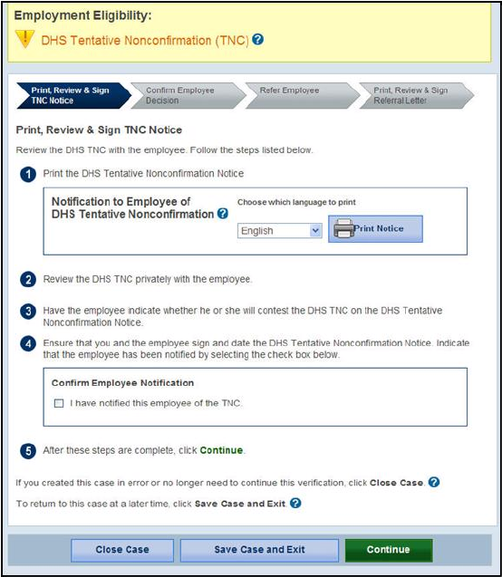
Image 11: DHS Tentative Nonconfirmation—Employee Decision Process
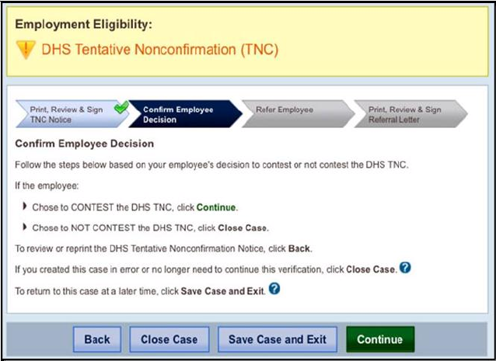
Image 12A: DHS Tentative Nonconfirmation—Employee Referral Process
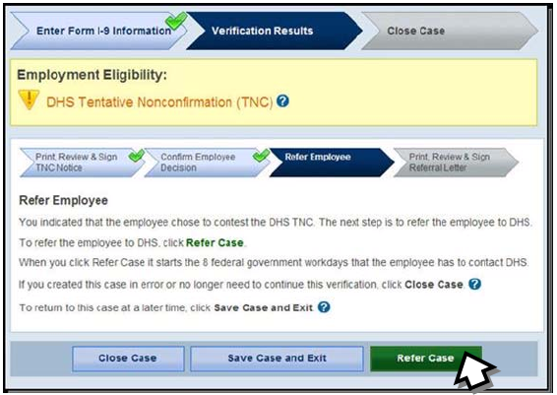
Image 12B: DHS Tentative Nonconfirmation—Employee Referral Process
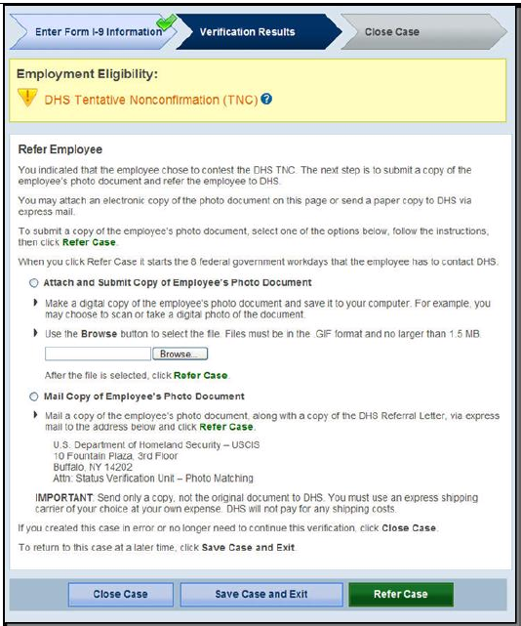
In the event that the TNC is not contested or is contested unsuccessfully, the employer will receive a “Final Nonconfirmation” (“FNC”) or a “DHS No Show” (which is considered an FNC). At this point, the employer must either terminate the employee or notify the Department of Homeland Security that it will continue to employ the employee. To the extent that an employee is terminated at this time, an employer will not suffer any civil or criminal liability even if the employee was authorized to work in the United States.
Image 13A: Final Nonconfirmation
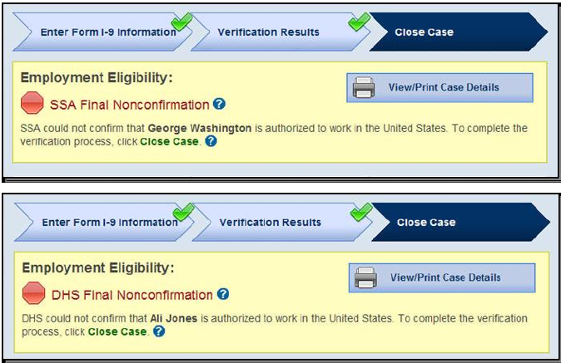
Image 13B: DHS No Show
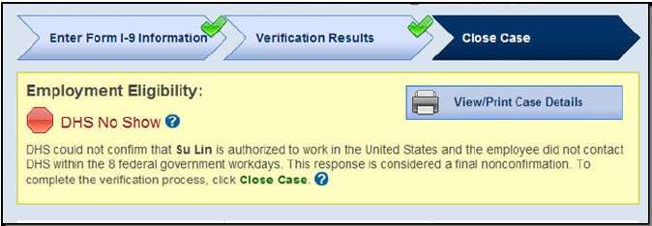
- How E-Verify Affects an Employer’s Liability under IRCA
Though it cannot be used as a safe harbor, an employer’s use of E-Verify can create a rebuttable presumption under IRCA that the employer did not knowingly employ an undocumented worker. Indeed, if an employer checks an employee’s status using E-Verify and receives an Employment Authorized result, but the employee turns out to be an unauthorized immigrant, there is a rebuttable presumption that the employer did not violate IRCA. On the other hand, if an employer continues to employ an employee after receiving a FNC, and the employee is subsequently found to in fact be unauthorized, then there is a rebuttable presumption that the employer did knowingly employ the unauthorized alien, in violation of IRCA. Id.
- Federal Requirements Regarding E-Verify Use
Under federal law, certain employers are required to use E-Verify while other employers are not. However, every employer who uses E-Verify must comply with certain requirements. The federal rules regarding who must use E-Verify and how it is to be used are discussed below.
- Obligations of Non-Federal-Contractor Employers
For employers who are not federal contractors, use of E-Verify is not required under federal law. If an employer decides to use E-Verify, however, it must become familiar with the detailed and oftentimes ambiguous rules regarding the system. First, employers who use E-Verify must read and accept the terms of the DHS’s E-Verify Memorandum of Understanding (“MOU”). Employers must also follow the enrollment and use procedures laid out in the USCIS Employer User Manual (“EUM”). Both the MOU and the EUM provide various rules regarding E-Verify use. While the employer’s counsel should consult the most recent versions of the MOU and EUM to determine what specific obligations are imposed, some of the key employer obligations are outlined below:
- Notice: The employer must notify each job applicant of the employer’s participation in E-Verify. An employer must “clearly display in both English and Spanish ‘Notice of E-Verify Participation’ and ‘Right to Work’ posters.”
- I-9 Obligations: An employer’s participation in E-Verify does not alleviate its obligation to use the I-9 system. Thus, an employer must complete an I-9 form for each newly hired employee before using E-Verify to check the employee’s work-authorization status.
- Limits on Use: An employer may only use E-Verify to check the work-authorization status of new employees. An employer may not use E-Verify to prescreen job applicants or check the work authorization status of employees who were hired before the company signed the MOU. Employers must E-Verify all new employees—selective use is not permitted and may be grounds for an employment discrimination action. The employer must initiate verification procedures within three employer business days of hiring the employee for whom verification is sought.
- TNC Obligations: If an employee receives a TNC, it must notify the employee, in writing and in private. The employer must also provide the employee with written instructions on how the employee may contest the finding. The employer may not take any adverse action against the employee until a FNC has been issued.
- Confidentiality: The employer must take steps to protect the confidentiality of any information it receives from the SSA or DHS pursuant to E-Verify. The EUM outlines the minimum steps the employer must take in order to preserve such confidentiality.

- Obligations of Federal Contractors
Pursuant to federal regulation, certain federal contracts must contain a provision imposing an obligation to use E-Verify upon the contractor. This rule only applies to “qualified” federal contracts, which generally means any contract for which the period of performance is 120 days or more, and the value of which exceeds $150,000. The regulations also require E-Verify provisions in subcontracts for services or construction, the value of which exceeds $3,000. The contractual provision required by the regulations imposes various E-Verify related obligations on contractor. In order to determine the specific obligations a particular contractor might face, a contractor’s counsel should consult the E-Verify Supplemental Guide and User Manual for Federal Contractors issued by the USCIS, the MOU, and the applicable regulations. Generally, however, federal contractors are subject to the following rules:
- Familiarity with Procedures: Contractors must become familiar and comply with the User Manual and Supplemental Guide for Federal Contractors. Contractors must also complete a tutorial on the use of E-Verify.
- Timeline for Compliance: Contractors must enroll in E-Verify and begin the verification process within a specified period of time after being awarded the contract. These deadlines vary depending on whether the contractor is a new E-Verify user, a current E-Verify user who is not registered as a federal contractor, or a current E-Verify user who is registered as a federal contractor.
- Employees who MUST be Verified: All new hires (whether or not assigned to a federal contract) and all existing employees who are assigned to the federal contract must be checked using E-Verify. This requirement does not apply to exempt employees, who may not be checked using E-Verify.
- Employees who MAY be Verified: A contractor may verify, but is not obligated to verify, its entire non-exempt workforce. If a contractor chooses this broader verification, it must notify the DHS when it enrolls or by updating its company profile on the E-Verify website.
- Exempt Employees: Employees who have continued to work with the same employer, and were either hired on or before November 6, 1986, or previously confirmed as authorized to work in E-Verify, may not be checked using E-Verify.
- Special Requirements for Certain Federal Contractors: Contractors that are an institution of higher education (as defined at 20 U.S.C. § 1001(a)), a state or local government, the government of a federally recognized Indian tribe or a surety performing under a takeover agreement pursuant to a performance bond need only verify employees (both existing and new) assigned to a federal contract.
- Employer Rules Still Apply: Except for the ability of federal contractors to E-Verify current employees, the rules for employers generally still apply.

- E-Verify Requirements Under State Law
In addition to federal legislation, many states have passed laws which affect an employer’s E-Verify obligations. The nature and scope of these laws vary. This variance is perhaps most pronounced when one compares the types of employers who are subject to the laws. For example, states have: (1) required all employers to use E-Verify; (2) required only certain employers (often public employers or public contractors) to use E-Verify; or (3) attempted (unsuccessfully) to prohibit all employers from using E-Verify. Penalties for violating state E-Verify legislation also vary widely. Indeed, penalties can range from losing certain state tax benefits, to ineligibility for public contracts, to criminal liability. Thus, employers operating in multiple states may be subject to different and even conflicting E-Verify requirements.
This paper will illustrate why employers need to be concerned about state E-Verify legislation by using Georgia, Nebraska, and Illinois as case studies. The laws of these three states aptly demonstrate the broad spectrum of state E-Verify legislation.
- Georgia: All Employers Must Use E-Verify
In July of 2011, Georgia enacted one of the broader pieces of E-Verify legislation. Not only are public employers required to use E-Verify, all private employers with more than 10 employees must also use the program. The deadline for compliance is staggered based on the number of employees the employer has: employers with 500 or more employees must comply by January 1, 2012, employers with 100 to 499 employees by July 1, 2012, and employers with 11 to 99 employees by July 1, 2013.
The new statute also prohibits counties and municipalities from issuing or renewing business licenses, occupational tax certificates, or other documents required to operate a business to an employer who has not provided evidence that it is using E-Verify or is exempt from such use. The required evidence consists of a standard-form affidavit, provided by the Attorney General, which attests that the employer uses E-Verify in accordance with federal regulations or has 10 or less employees. The law authorizes the Attorney General to conduct investigations and bring any criminal or civil action he or she deems necessary to ensure compliance with the law. Any person who knowingly submits a false or misleading affidavit under the new law may be subject to $1,000 fine and up to five years in prison.
- Nebraska: Public Employers and Contractors Must Use E-Verify
Nebraska’s E-Verify requirements are narrower in scope than the E-Verify requirements adopted by the Georgia legislature. Under Nebraska law, “public contractors” and “public employers” must use E-Verify to determine the work eligibility status of new employees physically performing services within the State of Nebraska. A “public contractor” is defined as “any contractor or his or her subcontractor who is awarded a contract by a public employer for the physical performance of services within the State of Nebraska.” A “public employer” is defined as “any agency or political subdivision of the State of Nebraska.” Every contract between a public employer and public contractor must contain a provision requiring the public contractor to comply with these E-Verify obligations.
In addition, a public construction or delivery services contract must require the contractor to submit an affidavit attesting that, among other things, the contractor has fulfilled its E-Verify obligations. Any contractor who knowingly provides a false affidavit pursuant to this contractual requirement will be liable for perjury. A second or subsequent false submittal will result in the contractor being barred from participating in public contracts for 3 years after the falsehood is discovered.
- Illinois: Employers Not Required to Use E-Verify
Illinois is on the more liberal end of the spectrum when it comes to E-Verify requirements. Indeed, in 2007 the Illinois legislature passed a law which prohibited any employer from using E-Verify until the program met a certain accuracy threshold. That law was challenged and eventually found invalid under the supremacy clause. The Illinois legislature responded by passing a less restrictive law which is currently in force. Under the current law, employers are not required to use E-Verify. Employers who choose to voluntarily enroll in the program, however, must meet certain requirements. Generally, Illinois employers who use E-Verify may not use the program to check the immigration status of current employees or to pre-screen prospective employees that have not been offered a position. (This is not allowed under the federal law, either.) The Illinois law also generally requires employers to comply with the notice provisions already required under Federal law. Employers who willfully and knowingly violate the E-Verify requirements may be liable for $500 per affected employee, plus costs, reasonable attorneys’ fees, and actual damages. Illinois also urges Employers who are considering enrolling in E-Verify to consult the Illinois Department of Labor’s website for current information on the accuracy of E-Verify and employer legal obligations with respect to E-Verify.
- Conclusion
Employers will likely become more eager to use E-Verify once they understand the potential liability they face for hiring an undocumented worker. Employers should note, however, that E-Verify use comes with a fair amount of state and federal regulation. In addition, public contractors may be required to use E-Verify under Federal and / or state law. An employer who fails to comply with this multi-level regulation may face substantial consequences. Thus, counsel for employers and contractors should familiarize themselves not only with federal E-Verify requirements, but also any requirements imposed in the relevant state jurisdiction.
Attachments

- I-9 Audit Protocol: Possible Method of Conducting an Internal I-9 Audit
- I-9 Internal Audit Report: Lessons Learned
- Practical Law Company, IRCA Violations: Assessing Employer Liability, PLC Labor & Employment, July/August 2012, at 68-73.

Miriam Jordan, Wall Street Journal, “Fresh Raids Target Illegal Hiring” (May 2, 2012).
8 U.S.C. § 1324a(a).
U.S. Citizenship and Immigration Services (“USCIS”), http://www.uscis.gov (2012).
Id. at § 1324a(b); 8 C.F.R. § 274a.2 (2009).
8 U.S.C. § 1324a(b)(1).
See Federal Register, Vol. 77, No. 59 (Tuesday, March 27, 2012) (p. 18256) for proposed revisions to the I-9 Form.
Id. at §§ 1324a(e)(4) and 1324a(f)(1).
Huynh, Loan T., Fredrikson & Byron, P.A. (2012), http://www.fredlaw.com/articles/realestate/real_1208_lth.html.
USCIS, http://www.uscis.gov/ (2012).
Id.
Id.
USCIS, Handbook for Employers: Instructions for Completing Form I-9 (Form M-274) (hereinafter “M-274”), available at http://www.uscis.gov/files/form/m-274.pdf (2012).
Miriam Jordan, Wall Street Journal, “Fresh Raids Target Illegal Hiring” (May 2, 2012).
8 U.S.C.A. §1101, et seq.
See supra M-274 at n.14, at Part 4.
See supra M-274 at n.14.
USCIS, http://www.uscis.gov (2012).
Id.
8 C.F.R. Part 274a.
USCIS, News Releases: Abercrombie and Fitch fined after I-9 audit (Sept. 28, 2010), http://www.ice.gov/news/releases/1009/100928detroit.htm.
U.S. Immigration and Customs Enforcement (“ICE”), Fact Sheet: Form I-9 Inspection Overview, http://www.ice.gov/news/library/factsheets/i9-inspection.htm (last visited Aug. 24, 2012)
8 C.F.R. § 274a.9(a) and (b).
8 C.F.R. § 274a.2(b)(2)(ii).
This percentage is calculated by dividing the number of violations by the number of employees for which a Form I-9 should have been prepared. Id.
Id.
Id.
8 C.F.R. § 274a.9(e).
The author wishes to thank Christopher R. Kortum for his assistance in drafting this portion of the article. Mr. Kortum graduated with highest distinction from the University of Nebraska College of Law in May 2012 and will join Woods & Aitken as an associate following admission to practice law in the State of Colorado.
8 U.S.C. § 1324a(a).
Id. at § 1324a(b); 8 C.F.R. § 274a.2 (2009).
8 U.S.C. § 1324a(b)(1).
Id. at §§ 1324a(e)(4) and 1324a(f)(1).
U.S. Citizenship and Immigration Services (“USCIS”), What is E-Verify? (Sep. 15, 2011), http://www.uscis.gov/e-verify.
USCIS, What is E-Verify: Companion to Form I-9? (Sep. 15, 2011), http://www.uscis.gov/e-verify.
All screen shots are from the U.S. Citizenship and Immigration Services, E-Verify User Manual for Employers 8 (May 2011) [hereinafter “Employer User Manual”].
No comment from the authors shall be made regarding the fact that we have to distinguish between “workdays” and “federal government workdays.” (“Federal government workdays” is the actual term used in the E-Verify Manual.)
Department of Homeland Security, The E-Verify Program for Employment Verification Memorandum of Understanding 4, (Sep. 1, 2009) [hereinafter “Memorandum of Understanding”].
See 73 Fed. Reg. 67651-01, 67652 (2008) (to be codified 48 C.F.R. Parts 2, 22, and 52); Memorandum of Understanding at 4.
Employer User Manual at 8.
Id. at 4.
Id. at 10.
Id.
Id..
Memorandum of Understanding at 4.
Employer User Manual at 10.
Memorandum of Understanding at 4.
Id. at 5.
Id.
Id.
Id. 6.
Employer User Manual at 11–12.
U.S. Citizenship and Immigration Services, E-Verify Supplemental Guide for Federal Contractors 4 (May 2011) [hereinafter “Supplemental Guide”].
Id. 20.
Id.
Memorandum of Understanding at 6.
Id. at 6.
Id. at 6–7; Supplemental Guide at 12–14.
U.S. Citizenship and Immigration Services, E-Verify User Manual for Federal Contractors 14 (May 2011) [hereinafter “Contractor User Manual”].
See Contractor User Manual at 14; see also Supplemental Guide at 16 (discussing exempt workforce).
Contractor User Manual at 14.
Supplemental Guide at 16.
Contractor User Manual at 16.
See Supplemental Guide at 5 (outlining use restrictions for contractors which are identical to those imposed upon employers). See generally, Memorandum of Understanding.
See Ind. Code §§ 6-3.1-13-18, 6-5.5-1-2, 6-3-1-3.5, and 6-3.1-13-5.
See infra section V(C)(ii), below [section discussing Nebraska law].
Id.; see also infra section V(C)(i) [section discussing Georgia law].
See Ga. Code Ann. § 13-10-91 (requiring public employers to use the “federal work authorization program”); Ga. Code Ann. § 13-10-90 (defining “federal work authorization program” as including E-Verify).
Ga. Code Ann. § 36-60-6(a).
Id.
Id. at § 36-60-6(d).
Id.
Id. at § 36-60-6(j).
Id. at §§ 36-60-6(h) & 16-10-20.
Neb. Rev. Stat. § 4-114(2).
Id. at § 4-114(1)(b).
Id. at § 4-114(1)(c).
Id. at § 4-114(2).
Id. at § 48-2911.
Id. at § 48-2912.
Id.
See United States v. Illinois, No. 07-3261 (C.D. Ill. March 11, 2009)
Id.
Ill Stat. ch. 820, § 55/12(c)(4) & (7).
Ill. Stat. ch. 820, § 55/12(b) & (c).
Id. at 55/15(d)(3).

