American Bar Association
Forum on the Construction Industry

Key Concepts of Demonstrative Aides

Michael Boucher
Trial Consulting Services, LLC
Tampa, Florida

Presented at the Midwinter Meeting
Making Dollars & Sense of Construction Damages
January 31 & February 1, 2013
Waldorf Astoria Naples Hotel, Naples, Florida

© American Bar Association

Preparing a case for trial is a two pronged endeavor. The first being the legal preparation of the case, which often times takes years, and the presentation of the case. The presentation of a case is the strategy and approach that will outline how the case is communicated to the trier of facts. One important aspect of case presentation is demonstrative aides. Demonstrative aides or evidence come in many forms and is often thought of as some type of graphic but is defined as,

actual objects, pictures, models and other devices which are supposedly intended to clarify the facts for the judge and jury: how an accident occurred, actual damages, medical problems, or methods used in committing an alleged crime. Many of these are not supposed to be actual evidence, but ‘aides’ to understanding. A model of a knee or a photograph of an accident scene obviously helps, but color photos of an operation in progress or a bullet-riddled body can excite the passions of a jury. The borderline balance between legitimate aides and evidence intended to inflame a juror's emotions is in the hands of the trial judge.

Prejudicial versus probative is the measure the Court uses but often the real measure is recovery versus cost. Removing labels of judge, jury, arbitrator, etc., people today have come to expect a cogent and organized presentation of information, in this case, evidence. The need for demonstratives is real but the cost to create can be a barrier, in particular when the case is not a high dollar case. Therefore, the crucial point is how to create a demonstrative from an understanding of what is being illustrated, communicated and how to make it persuasive to the trier of facts.
The “Chicken Bones Case”
Demonstrative evidence is nothing new at trial. The complexity and media used for demonstratives has evolved over time, but they have been used for hundreds of years. In 1857, Abraham Lincoln had a medical malpractice case that came to be known as the “Chicken Bone Case.” This case involved a carpenter, Samuel Fleming, who was injured as a result of a chimney collapse whereby he broke both of his legs. The plaintiff alleged that the doctors, Thomas Rogers and Eli Crothers, had set his legs incorrectly causing the bones to heal improperly leaving his legs crooked and one leg shorter than the other. In March of 1856, Samuel Fleming filed a law suit seeking $10,000.00 in damages. Lincoln was retained by the doctors as their defense attorney.
In what was seen as a plaintiff friendly case, Lincoln used two chicken legs to demonstrate the anatomy of bones.
Lincoln saved his lesson on how bones heal for his summation to the jury. Then, holding up two chicken-leg bones–one from an old chicken and the other from a young one–he demonstrated to the jury their respective texture and resilience. The bones of the young bird were supple, while those of the old chicken were brittle and broke easily. Fleming, being in middle age, Lincoln pointed out, would have bones more closely resembling the latter than the former. Unable, according to Lulu Crothers, to ‘remember about the lime or calcium deposited in older peoples’ bones,’ Lincoln told the jurors that the bone from the older chicken, ‘has the starch all taken out of it–as it is in childhood.’

This graphic demonstration had the desired effect on some of the jurors, a majority of whom probably entered the courtroom predisposed toward Fleming and prejudiced against the more affluent defendants. After 18 hours of deliberation, the jurors failed to reach a decision.

The case was later settled, but what Lincoln did in that case was to use demonstrative evidence or aides to persuade the jury through education. In order to see the magnitude of the impact that the chicken legs played in that trial, stop and think how Lincoln could have educated the jurors in the absences of a demonstrative. Not only did Lincoln educate, he also persuaded the jury. The simple truth is that it would have been difficult to accomplish what Lincoln did without a visual aid. Most people are visual learners, which was true then and even more so today. The same principles apply today as they did in 1857, and attorneys need to consider this as they are developing their case and deciding on what demonstratives are needed.
Fundamental Approach
Demonstratives come in many different shapes, sizes and forms; from a traditional exhibit board, to an acetate flip chart, PowerPoint, a physical 3-D model, or an animation to Electronic Trial Presentation (ETP).
The key to creating any useful demonstrative is to first answer the question: what do I need to communicate and why is it relevant? Keep in mind that demonstratives should be used to educate, summarize, construct and/or validate evidence. A fundamental rule for any presentation, and more importantly in trial, is to have an organized and seamless presentation. Although this seems obvious enough, often times we see either gaps in a presentation or too much information with unneeded overlap and redundancy. Demonstrative aides are not a magic wand or some object that will mesmerize a jury or judge; instead, your visual aides should be a culmination of the evidence.
Know Your Audience
Understanding your audience is one of the most important factors in creating a demonstrative. Who is your audience, judge, jury, or arbitrator? Think for a moment about society today and how we as Americans get our information. Not just the media on which we receive it, but its format and content. In today’s Information Age, people now receive their information in a digital format often times with pictures, videos, animated graphics and concise summaries that don’t require much reading. If that is the customary manner in which most people receive information, why would one not adopt a similar communication design in the courtroom?
Not only is the type of trier of facts important, so is venue. If you are unfamiliar with the attitudes and predispositions of a particular venue, educate yourself. I am reminded of a case in Bradenton, Florida where one of the parties retained a reputable legal graphics company out of Washington, DC to create demonstratives aides. The case involved the use of alter egos created by the defendant to commit fraud. In an effort to communicate the use of the defendant’s alter egos, the consultants created demonstrative boards that visually identified the corporations as the defendant. Unfortunately the DC based firm was not aware of the conservative nature of the area as well as the Judge. The Judge ruled that the demonstratives were overly prejudicial and that the boards would not be allowed to be used at trial.
Adding Persuasive Power
Creating demonstrative aides is both technical as well as artistic. Likewise, the demonstratives themselves are contextual and aesthetic. Therefore, thought must be not only put into what goes on the demonstrative, but also how it will look and will be displayed. In creating an effective demonstrative you first start with the technical aspect. What is the supporting evidence and how will that evidence tie into the demonstration? A timeline is a good demonstrative to illustrate this concept. In almost every case we work on we create a timeline. This provides the lawyers with a visual summary of their case which is used to guide the trier of facts through the evidence. It puts all relevant facts and events in order with a brief and concise summary. In addition to that information, we often place exhibit number, bates number, testimony cites and witness name in each entry on the timeline as appropriate.
Moreover, we may also color code the like entries and apply icon representations or company logos for ease of recognition and retention. This provides the jury an organized visual summary of the case that has been tied to the evidence. If created properly, the timeline can be used from openings through the summation of a case. In opening statements it will give the attorney a tool to review the events in the sequence they occurred and to relate those to the jury with an understandable overview. Remember Lincoln’s chicken bones. Not only did he use the demonstrative, he also related it to the jurors.
Lincoln was unable to remember the technical aspects of lime and calcium deposits so he represented it in a way that was simple and easily understood by the jury. Knowing how to relate your demonstrative to the jury is almost as important as the content. This will also provide the opportunity to establish a rapport with the jury as you use the timeline throughout the trial.
During the evidentiary phase of the trial, the lawyer publishes the evidence to the jury and references the corresponding entries on the timeline, building the credibility of the demonstrative and of the case. Finally, the timeline is used during closing arguments, referencing each entry and citing the evidentiary source of each as the jury is walked through what the evidence has proved.
Construction Damages Case Example
The same concept can be applied to other demonstratives as well. Damages are often similar in how they communicate the evidence to the trier of fact. An effective demonstrative that illustrates damages is one that not only shows the evidentiary sources, but also the magnitude of damages. In one case, we developed a demonstrative to illustrate the cause of the damages using PowerPoint® that allowed the lawyer to visually build the elements of the damages claim. The case involved a construction management company whose responsibilities, among others, were leasing, design, permitting, bidding, contracting and execution. The contract outlined once a lease was executed that there was a 120 day window whereby the defendant was to complete the design, permitting and bidding, thereby allowing the proper time frame for mobilization and construction. The deadline for the completion of all work and for the lessees to take occupancy was November 17, 2006. The defendants claimed that the delay in completing the tenant improvements, or build out, was a result of change orders and not that of the defendant’s actions or lack thereof. In order to educate the jury on how the process worked we created a timeline as the backdrop for the interactive demonstrative.
The demonstrative was used to illustrate the delays and their causes based on the contract schedule. There were four timetables which were illustrated: main building, site improvements, garage and tenant improvement/interior, with the last being the relevant issue at hand. The tenant improvement schedule allowed an eleven and a half month window for all work to be completed (see figure 1). Through the use of Electronic Trial Presentation (ETP), we published to the jury the build out schedule from the executed leases which were stated in number of days. The demonstrative had this information for each tenant.
The initial concept was to link the evidence to the interactive demonstrative. This would allow the attorney to simply point and click to publish the supporting evidence, much like navigating a familiar media, a website. In order to keep the costs contained we altered this concept and utilized computer based Electronic Trial Presentation to publish the documents rather than linking to the demonstrative itself.
Subsequently the jury was provided, tenant by tenant, the issue date for the building permits and each of these related to the dates on the visual aid (see figure 2). This was followed by the actual time it to took from permit to the certificate of occupancy represented by a line spanning that timeframe. Within the timeframe bar of the aid, we numerically listed total days from permit to CO. This allowed for the aid to communicate the duration numerically as well as a visual time span.
In order to show the effect of the change orders, we extended the bar to show the build out schedule per the lease agreements. With a separate color bar on the same plane, we added the time effect of the change orders per those signed orders. All of the supporting evidence, the actual leases, change orders, etc., were published to the jury and related back to the demonstrative.
The net effect at the end of this trial was that the plaintiff had proven to the jury that the real cause of the delays was the defendant failing to execute the leases timely, thereby impacting the pre-mobilization phase of the project which included obtaining necessary building permits. The jury was then left to add up the amount of damages.
Once we had communicated and proven the delays and the true cause our damages were easy to quantify. We simply constructed a bar chart that outlined the cost for each tenant who was impacted and the corresponding dollar amount. These amounts were easily quantifiable by the lease terms and projected parking revenues. To create an easy to follow demonstrative we color coded each tenant with a separate color and added texture to delineate rent and parking revenues.
An alternative to using a created demonstrative to show the economic damages could have been a basic approach of using butcher paper to write a list of tenants and the economic damages. Communicating to the fact finder is strategic and often times the old fashioned way of doing things may be the most persuasive way of doing things.
These two cases are examples of using demonstratives to present the facts of the case in a clear and understandable format which is supported by the evidence of the case. Supporting a demonstrative with evidence can be quite a task. If a demonstrative doesn’t have evidence references, isn’t in an organized and cogent fashion, how does the fact finder know what the evidence really shows? You can blow up the key documents and testimony on boards but that is a cumbersome and potentially detrimental to your case. An attorney who appears disorganized at trial is a consistent complaint we see in our jury exit surveys. Boredom and lack of understanding would round out the top three that we see.
Using Electronic Trial Presentation (ETP) to Focus
An alternative is to create a PowerPoint® or Keynote® presentation that contains embedded documents or testimony. This is highly discouraged as there is a large amount of preparation time and more importantly it’s the wrong way to do it. These programs are designed for static linear presentations. Trial is not static and publication of evidence is not linear.
The most persuasive approach is electronic publication through a document camera, commonly referred to by the brand name Elmo™ or computer based using a program such as Trial Director™ or Sanction™. Both the document camera and computer allow attorneys to publish documents, transcripts and photos to the fact finder quickly and seamlessly. The documents can become demonstratives, at times even admitted as evidence when annotated by a testifying witness. Moreover, this technique allows the lawyer to have a demonstrative on a board and to validate or construct the contents of it with evidence on a screen or monitor.
When presenting a construction case to arbitrator, judge or jury the main objectives are focus and management. Construction cases are often document intensive and those that are not generally include evidence which is difficult to present. Oversized exhibits and photos of faulty construction are two good examples. Attorneys often ask how to blow up an exhibit that is oversized, or already blown up, or to communicate faulty construction and how it deviated from the plans or where it was located at the project site.
The use of Electronic Trial Presentation (ETP) provides a modality by which evidence is easily managed and presented. When a case is properly prepared the trial attorney simply requests an exhibit and it is published to the trier of facts. Deposition testimony is presented either in transcript or video form with a simple deponent name and page line reference. At the attorney’s or witness’ direction, exhibits are annotated with highlights, arrows and many other tools (See figure 3). Moreover, the ability to zoom in on particular aspects of oversized documents allows the audience to be focused on the particulars of that exhibit.
The proper trial system allows for the management of documents, photos, videos, animations and demonstrative aides. The dynamic nature of these systems allows for dynamic access to all of the information loaded. The ability to compare or contrast two or more pieces of evidence is present in a vast majority of construction cases. Moreover, these systems allow trial attorneys and witnesses to focus the triers of facts on the particular parts of the evidence that educate and persuade them.
Disaster Recovery Plan
Using technology at trial raises many fears with even the most tech savvy attorneys. The main fear that they have is what if it doesn’t work. The first step is to test all equipment prior to use. Not only for the reliable functionality but also the computer file formats. At times, video playbacks have conflicts between the computers video codecs and the projector or certain projectors don’t properly display highlights and other annotations. Prior to trial is the time to discover and resolve any functionality issues.
Once the courtroom setup has been tested, it is crucial that the main failure points are identified and a disaster recovery plan is outlined. The most common failure points at trial are the computer (e.g., laptop, ipad, etc.), the projector, most commonly the bulb, and cabling. Whether ETP is being provided by an internal consultant, paralegal or a third party, it is crucial that the trial computer has a mirror copy. With a redundant computer and a video switch any potential computer failure is averted by switching to the redundant system during a failure.
Likewise it is standard operating procedure to have additional cables and a second projector, or at minimum a bulb, in the courtroom and easily accessible. A failed cable or projector can be put online in a few minutes with little to no impact to the presentation of the case. The old adage of proper preparation prevents poor performance is seminal to trial presentation. This adage is true to every aspect of trial presentation and in particular demonstrative aides.
Identifying and Avoiding Pitfalls
Demonstratives are to aid the trier of fact in understanding the evidence and case. Unfortunately there are times that demonstratives are not an aide, but hindrance to a case. What makes a demonstrative a hindrance to a case? The most damaging hindrance is if the judge excludes the demonstrative from use at trial. The two causes for exclusion are inaccuracy and prejudicial effect.
It is up to the attorney or experts to provide the artist accurate information or data by which they will construct your graphic. One rule to follow in creating demonstratives is to cite the evidentiary sources of the demonstrative so the judge can reference the evidence in determining its accuracy. If ETP is used in your trial, an exclusion of a demonstration does not create an insurmountable hindrance. Rather than using the demonstrative, the trial attorney simply publishes the evidentiary sources and can create the demonstrative by using butcher paper and a marker. Sometimes this is a very effective presentation method.
When a demonstrative is created with a persuasive format or visual support there is a risk that opposing counsel may object and the judge may sustain that objection. Two ways to avoid this exposure from hindering your case is first to provide demonstratives to opposing counsel in advance of its use, forty-eight hours is recommended unless the court has a different time table, and to ask for any objections prior to its use. As with the technology, it is recommended in this example, that a sterile factual version of the demonstrative be created that is less persuasive or prejudicial as the fail safe. Just because a demonstrative is allowed to be used at trial doesn’t mean it will help your case.
The most often seen error that hinders a case is trying to put too much information in a demonstrative. A demonstrative with a large amount of information is possible but almost always requires an electronic media that allows for interactivity. To create a static exhibit that overwhelms the trier of facts with information creates confusion, which in turn affects understanding and retention. Our society is bombarded with information and images. Our society has evolved to the point where our attention span has declined as a whole. Demonstratives with excessive information are asking people to process information differently than they do in everyday life.
Another common mistake is the over use of bullet type aides. Only on rare occasions should such aides be used. They add little to nothing to the presentation of your case and can become frustrating to the jury as well as create a disinterest in your case. If bullet aides are ever appropriate it would be as a constant reference to either key elements of the case or parts of your damages claim. Moreover, these types of reference aides should almost always be used in a board format. Some feedback we receive in our exit surveys regarding demonstratives, and in a particular, bullet points, is that jurors feel they are unnecessary and add nothing to the presentation of the case.
An additional one to avoid is the use of poor quality images or clip art. The aesthetics of your demonstrative carries weight with fact finder. Both clip art and poor quality communicates to the jury that the case is not serious as well as a lack of effort and concern for the case. If we keep in mind how society receives information it will show in the aesthetics of a demonstrative.
There are some basic concepts in how people perceive visual information. One is symmetry. People like to see information in a consistent, uniform and organized fashion. Another concept is quality. Use photos rather than clip art or cartoon type graphics. Another is familiarity or ability to recognize. Use universal icons such as a caduceus or red cross to represent medical providers.
Conclusion
By incorporating common and easily recognizable representations in demonstratives you are easing the burden of understanding and retention on the fact finders. The ultimate goal of demonstratives is to have the judge, jury or arbitrator have an ease of understanding and retention of what it represents.
The impact that trial presentation, including any demonstrative, has in a case is predicated on the strategic thought of what it will communicate to the trier of facts, and why it is relevant for them to know.

Figure 1. (Created in Microsoft PowerPoint)
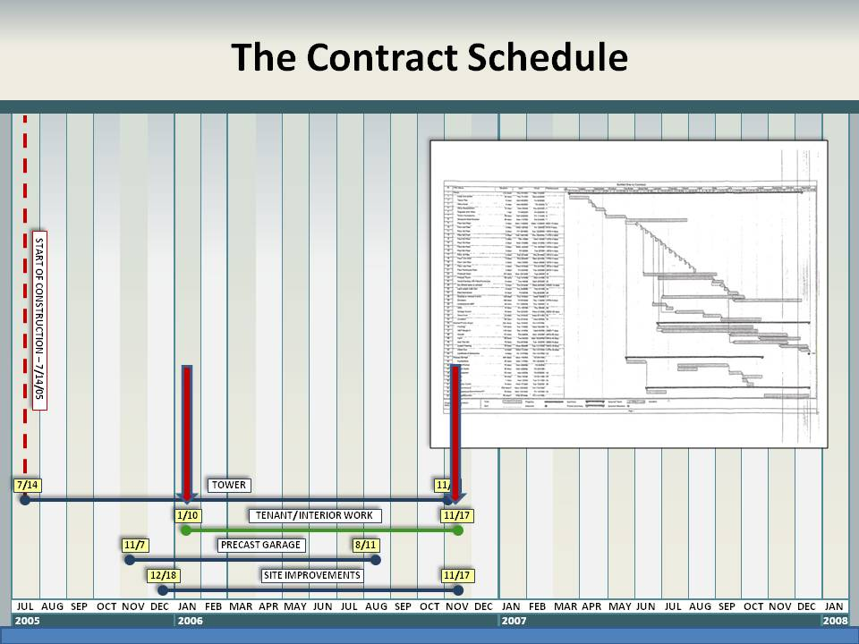

Figure 2. (Created in Microsoft PowerPoint)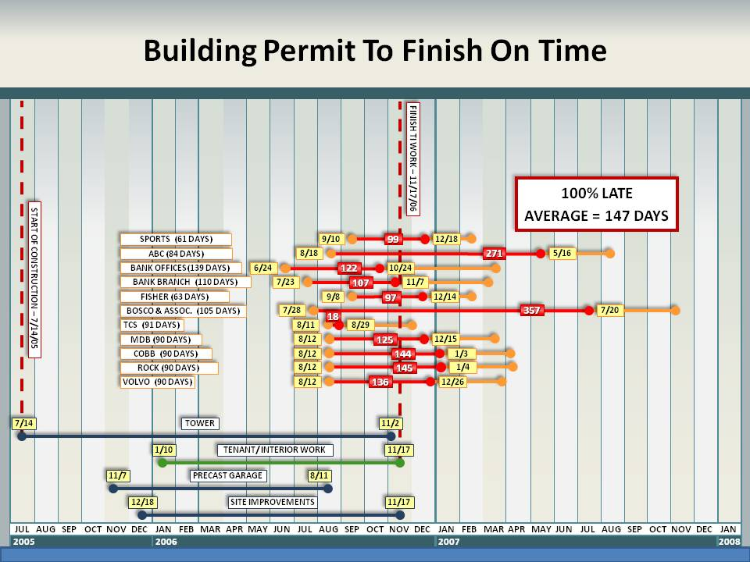

Figure 3. (Created in Sanction by LexisNexis (formerly Verdict Systems))
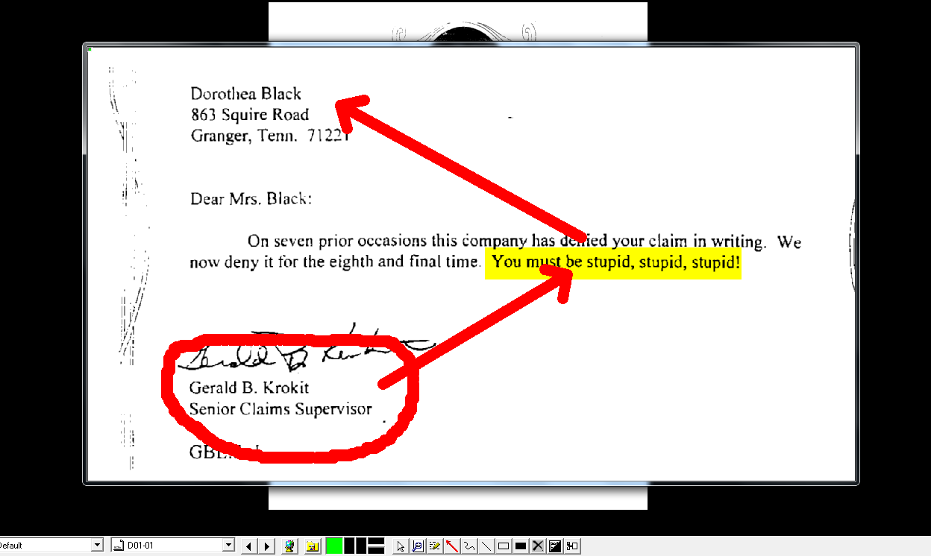

Black’s Legal online dictionary.
Samuel G. Fleming vs. Dr. Thomas P. Rogers and Eli K. Crothers, Weider History Network: HistoryNet; Charles M. Hubbard is the Dean of Lincolniana and Associate Professor of History at Lincoln Memorial University. This article was originally published in the August 1998 issue of American History magazine.
Samuel G. Fleming vs. Dr. Thomas P. Rogers and Eli K. Crothers, Weider History Network: HistoryNet; Charles M. Hubbard is the Dean of Lincolniana and Associate Professor of History at Lincoln Memorial University. This article was originally published in the August 1998 issue of American History magazine.
John Grissom, Rainmaker Dell; Reprint edition (December 27, 2011)

